This document is a walkthrough of the configuration of Active Directory in Lab IA462. The domain controller is setup, and Remote Desktop and Network Time Protocol settings are configured. The second part of this document reviews any errors or issues that occurred during the lab.
Install and Setup AD
The first thing I did was install updates and verify my Windows Server had connectivity. In the Server Manager, I installed Active Directory. I ran the command Install-WindowsFeature -name Ad-Domain-Services -IncludeManagementTools in PowerShell. Then I opened the Active Directory Domain Services Configuration Wizard. I added a new domain forest called ia462.advossec.com during Post Deployment Configuration. I kept the default NetBIOS name IA462.
Reconfigure DHCP and DNS
I configured the DHCP server in PFsense to use the Domain Controller 192.168.156.77 as the DNS server. I set the same DNS for the Windows and Linux networks, then I added a secondary DNS as the firewall for each network, 192.168.156.1 for Windows and 192.168.156.129 for Linux. Then I configured the Domain Controllers IP address to be static.
I went to the adaptor settings on the domain controller and added the static IP address. Then I added PFsense as a host in the DNS Manager.
Create OUs
The first domain I created was IA462. I created the directories of Compute, Users, and Groups. I saved time in adding all of the directories using PowerShell scripting. Then I added users to the administrative and normal directories and created the email domain. Then I created an security group for admins.
GPOs
In Group Policy Management, I created a Group Policy Object named NTO-DC for the time server. I configured the Windows Time Service to enable Global Configuration. Then, in Time Providers, I enabled the NTP client. I configured the Windows NTP client to use the domain controller.
Then I created an inbound rule under the Windows Defender Firewall for the NTP Client. I also created a group policy for Active Directory Domain Services to allow it in Windows Defender Firewall.
After that I created an RDP GPO for remote desktop login. Under the remote desktop service, I enabled Allow users to connect remotely by using Remote Desktop Services. Then I enabled a high encryption level in the RDP security settings. I enabled Allow remote connections from computers running Remote Desktop with Network Level Authentication. Then I added the predefined rule to allow the remote desktop. Then I linked the NTP, RDP, and firewall GPOs to the Domain Controllers Policy. Then I linked the RDP and NTP client to the Computer OU. I updated group policy in the PowerShell command line and verified that RDP was enabled on the computer.
I verified the time zone was EST on the Linux manager and joined it to the domain running realm join ia462.advossec.com -U pa-ramey. I updated timesyncd.conf to set the domain as the time server. Then I changed sssd.conf to not use fully qualified domain names. In sudoers.d/10_AD I added the Linux admin group and added the Linux Mgr to it.
Lastly, I added the Windows 10 client I installed from the MDT to the domain as a privileged user and made them an administrator on the domain.

Troubleshooting
Issues Deploying Server
I had issues before even starting the lab. The last part of Microsoft deployment kept throwing errors. The mdt error kept saying the task sequence was incorrect. So after several task sequence configurations, I looked up more specifically the VerifyBootEX part of the error and found it was a bug with the updated Windows ADK. I had to add a command to the task sequence to specify whether the operating system is using a UEFI or a regular boot system.
DHCP Reconfiguration
After I configured the Domain Controller to have a static IP, I also configured the MDT to have a static IP. I was worried my MDT server would somehow lose its IP address, so I created an additional pool of IP addresses for the Linux network, to separate them and leave the MDT IP address out. It seems a DHCP reservation would have been more convenient, so I’m not sure why I did this. So just deleted the extra pool I had after statically assigning the IP.
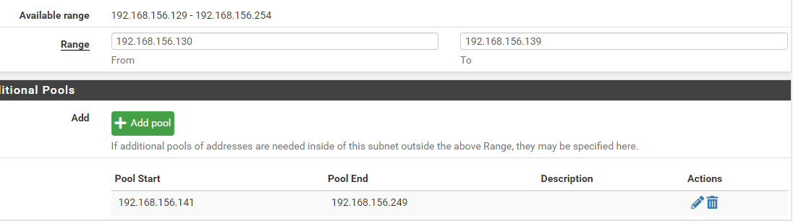

Time Zone Doubt
The time zone was already set to America\Detroit but was displayed EDT instead of EST. I tried to change this to match the EST that was displayed in the walk through. I changed the EDT to EST in the localtime.conf file, but that didn’t change the way the terminal displayed it as EDT instead of EST when checking the time and date status. I tried to change the time to New York, but it still displayed EDT. It was still Eastern Standard Time, so I left it.
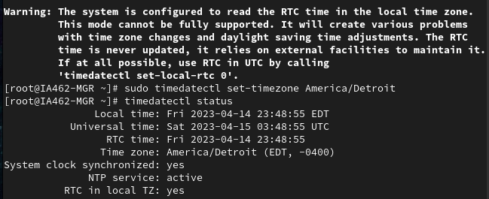

Resources

- Fix Failure (5616): 15299: Verify BCDBootEx | Windows 10 ADK 2004!
Retrieved from: https://www.youtube.com/watch?v=W4Xfen6Slrk
- FixUEFIDetection.wsf
Retrieved from: https://github.com/DeploymentResearch/DRFiles/blob/master/Scripts/FixUEFIDetection.wsf

